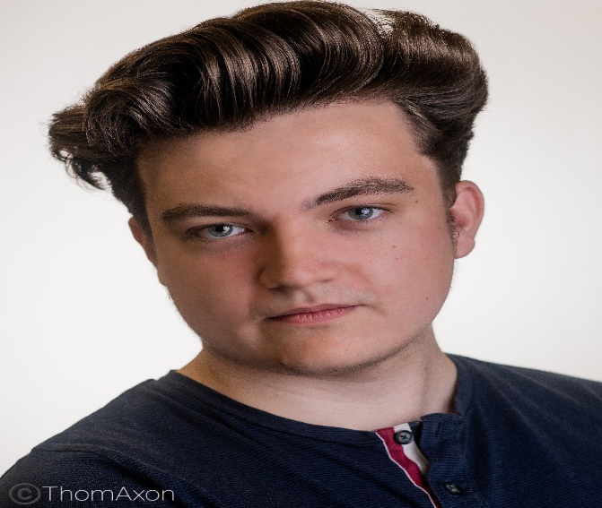
Location: East Midlands
Height: 5,10
Eye colour: Green/Brown
Hair colour: Brown
Hair length: Short
Playing age:16-25
Appearance: White/Slim Build
Voice character: Comedic/Natural
Voice quality: Friendly/Warm
Singing range: Bass/ Tenor/ Baritone
Accents
Midlands(Nottingham/Derby), Northern
General American
Training
2018-2021, Acting BA (Hons), Falmouth University,
2018- National Youth Film Academy, Set Ready course
2021-Perfom Teacher Training, Perform.org.uk
Other
2020-Theatre-Solo Performance-Falmouth University
2020-Member of Equity-Michael wood
Workshops
2021-Accent- Elspeth Morrison

Skills
Radio presenting
Screen and stage experience
Voice-over work
Teaching
Pantomime

Panto
Performance
Comedy, screen acting, Comedy Improv, Outdoor Performances, Physical Theatre, Story Telling, Naturalistic, Musical Theatre, voice over, tv acting, Shakespeare. Presenting, Film
Dance and Physical theatre
My fitness levels are High, and my movement qualities are strong, I learn Choreography quickly and I have devised and worked on a solo theatre Performance.

Credits
Year-Type of performance- Role, Name of Production, Company-Location, Director
Michael Wood
Spotlight Pin:0630-1274-2422
Contact Details
Email Address: Mike.wood99@hotmail.com
Phone number: Available upon Request

- 2021-Screen-James (Lead), The Fixer, Student Film-Falmouth, Elliott Ferguson
- 2021-Screen-Voice (Lead), Saturday Night Sunday Morning ,Student Film-Nottingham, Tom Watchorn
- 2020-Screen-Norman (Lead), A VERY ENGLISH SCANDAL, Falmouth University, Sarah Glasspool
- 2020-Screen- Tony (Lead), SCRATCHCARD, Student Film-Falmouth, Daniel Hollies
- 2020-Screen- Paul (Lead), GAME, Falmouth University, Caroline Jefferies
- 2019-Screen-Beach Dweller (Supporting), WILDERNESS, Student film-Falmouth, Rebecca Raine
- 2018-Screen- Rationality (Supporting), INNER SPEECH, Student Film-Falmouth, Jacob Ström
- 2017-Screen- Interviewer 1 (Supporting) , HOW DO YOU COPE UNDER PRESSURE, National Youth Film Academy-London, Nicholas Hulbert
- 2017- Screen- WAR_ZOMB13 (Lead), GAME OVER, Student Film-Nottingham, Andres Ortiz Pinilla

MUSICAL THEATRE

- 2019-Theatre- Jacob Rosenbloom/Ensemble, URINTOWN, Tremough Follies Musical Theatre Society -Falmouth, James D`Arcy
- 2016-Theatre- Ensemble/guard, JESUS CHRIST SUPERSTAR, The Peoples Theatre Company-Nottingham, Chris Teasdale
- 2015-Theatre-Ensemble/Bisset, JEKYLL AND HYDE, The Peoples Theatre Company-Nottingham, Chris Teasdale

Screen
- 2021-Stage-(Simeon) (Lead/Supporting), THE SEAGULL, Falmouth University, Amanda Collins
- 2021-Stage- Hendrix (Lead), THE CHICKEN SHOP, Falmouth University, Mark Laville.
- 2020-Theatre- (Lead) Solo, THE OTHER WORLD, Falmouth University, Sue Smith
- 2020-Theatre-(Lead), Constellations, Falmouth University, Gareth Farr
- 2017-Stage-Alex Stokes (Lead), MUSICAL DIFFERENCES, National Theatre Connections Festival-London, Amy Legge
- 2015-Stage- Captain Hook/Mr Darling (Lead), PETER PAN, Centre Stage Performing Arts Studio-Ilkeston, Martha Woodcock
- 2014-Stage -Phileas Fogg (Lead), AROUND THE WORLD IN 80 DAYS, Centre Stage Performing Arts Studio- Ilkeston, Martha Woodcock

Voice over
- 2021-Variety of commercials (Material), Various Roles, (Supporting), Falmouth, Michael Wood
- 2021-childrens book example, Various Roles, (Lead/Supporting), Falmouth, Michael Wood
- 2020-Radio Drama, Stigma, (Lead/Supporting), Falmouth University, Nicola Coplin
- 2020-Radio Drama, Price We Pay, (Lead/Supporting), Falmouth University, Nicola Coplin
- 2020-Radio Drama, The First, (Lead/Supporting), Falmouth University, Nicola Coplin

